EXAMPLE

8

9

7

2

4

5

8

6

YOUR NAME: _________________________________
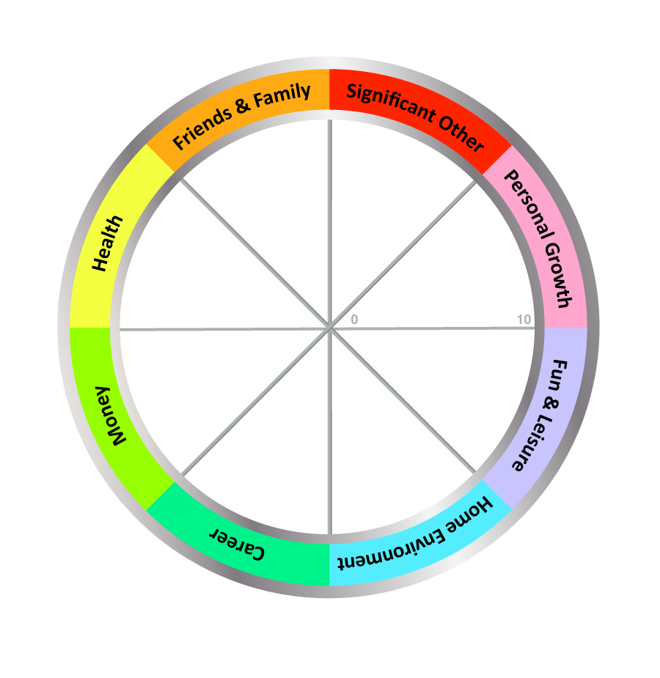

TODAY'S DATE: ____________________

COMPLETE THE WHEEL:

1. Review the 8 Wheel Categories - think briefly what a satisfying life might look like for you in each area.

2. Next, draw a line across each segment that represents your satisfaction score for each area.

- Imagine the centre of the wheel is 0 and the outer edge is 10
- Choose a value between 1 (very dissatisfied) and 10 (fully satisfied)
- Now draw a line and write the score alongside (see example above)

IMPORTANT: Use the FIRST number (score) that pops into your head, not the number you think it should be!

If necessary you can split category segments to add in something that is missing, or re-label an area to make it more meaningful. Examples of changes are:
  - Family and Friends: Split "Family and Friends" into separate categories.
  - Significant Other: Changing the category name to "Dating", "Relationship" or "Life Partner".
  - Career: Changing the category name to "Motherhood", "Work", "Business" or "Volunteering".
  - Finances: Changing the category name to "Money", "Financial Security" or "Financial Wellbeing".
  - Health: The category name could be split or changed to "Emotional", "Physical", "Fitness", "Spiritual" or "Wellbeing".
  - Home Environment: The category could split or change to "Work Environment" for career or business clients.
  - Fun & Leisure: The category name could change to "Recreation"
  - Personal Growth: The category name could change to "Learning", "Self-Development" or "Spiritual"
  - Other categories to add could include "Security", "Service", "Leadership", "Achievement" or "Community".

